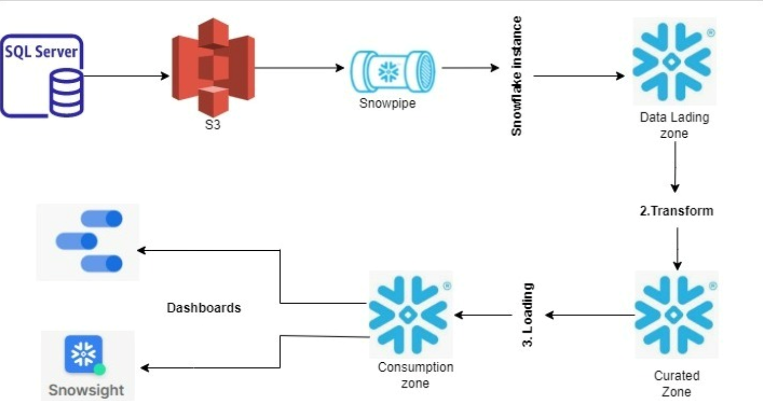

USE CASE

- Built a simple and commonly used domain and we can call it customer sales.
1.customer data
2.orders data
3.salesman data
- We are implementing ETL workflow

Phases of project

- History loading, or full loading,or raw data loading.
- Incremental loading

